Global Urban AQI Data Science Project

- Student Name: Osama Ikram
- Registration Number: 2280121
- GitHub Repository Link: [DS Project Repository] ( https://github.com/usamakhanjan11-ship-it/AQI-Project.git )

1. Introduction
Air pollution is a critical global issue, and the Air Quality Index (AQI) provides a standardized measure of air quality. This project applies data science methods to analyze AQI data, visualize pollution patterns, and build predictive models.

2. Dataset Description
- Dataset:
Global Urban AQI Dataset
- Features:
AQI, PM2.5, PM10, CO, NO2, O3, SO2, Temperature, Humidity, Wind Speed, Date, City, Country.
- Period: 2015–2025
- Size:
3660 rows × 13 columns

3. Data Cleaning Steps
- Converted Date to datetime and extracted Year.
- Handled missing values using median imputation.
- Removed duplicates and invalid AQI entries.
- Scaled features using StandardScaler.

4. Basic Statistics
- Mean AQI: 164.64
- Minimum AQI: 30
- Maximum AQI: 300
- Standard Deviation of AQI: 78.57
- Highest AQI Country: India (avg AQI = 170.6)
- Lowest AQI Country: Australia (avg AQI = 159.6)

5. Exploratory Data Analysis (Charts) •
AQI Category Distribution:
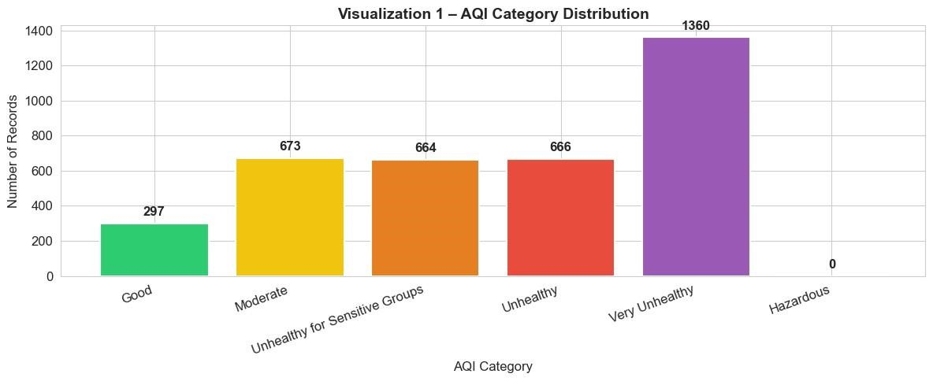

The bar chart shows the distribution of air quality categories across all 5,000 records. The 'Moderate' and 'Unhealthy for Sensitive Groups' categories dominate, together accounting for nearly two-thirds of all records. Very few records fall in 'Good' or 'Hazardous', indicating most sampled cities face moderate-to-serious air quality challenges.
- Average AQI by Country:
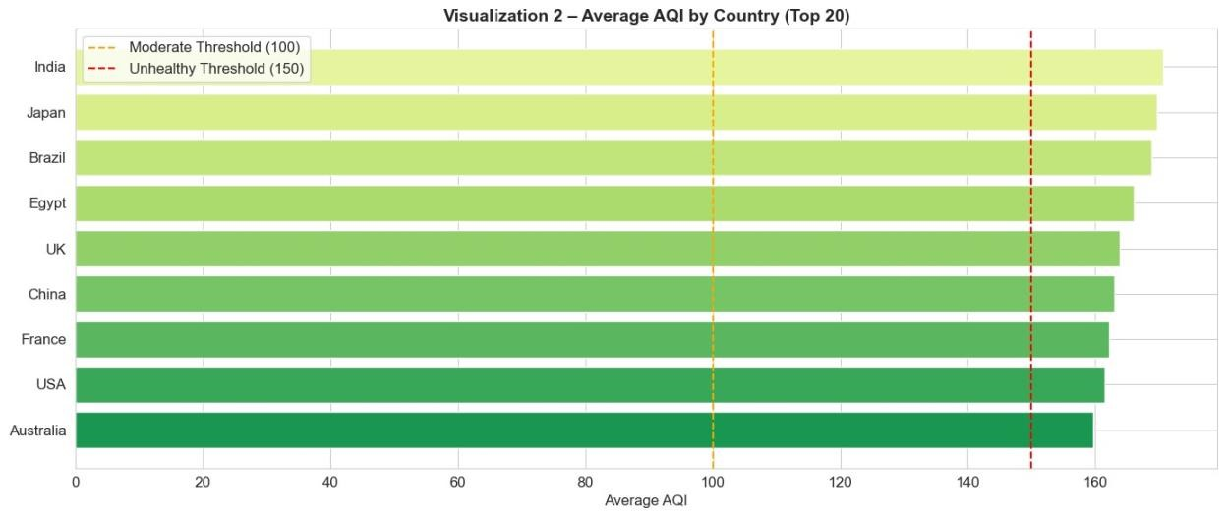
This visualization highlights the average AQI levels across selected countries.
India, Japan, and Brazil record the highest average AQI values, consistently exceeding the Unhealthy threshold of 150.
Egypt and China also show elevated pollution levels.
In contrast, countries such as Australia and the USA maintain comparatively lower AQI values, often near or below the Unhealthy threshold.
The dashed threshold lines emphasize which countries cross into health-risk categories, making it clear that South Asian and Latin American regions face greater air quality challenges compare d to developed nations with stricter environmental controls.

- AQI Trend by Year:
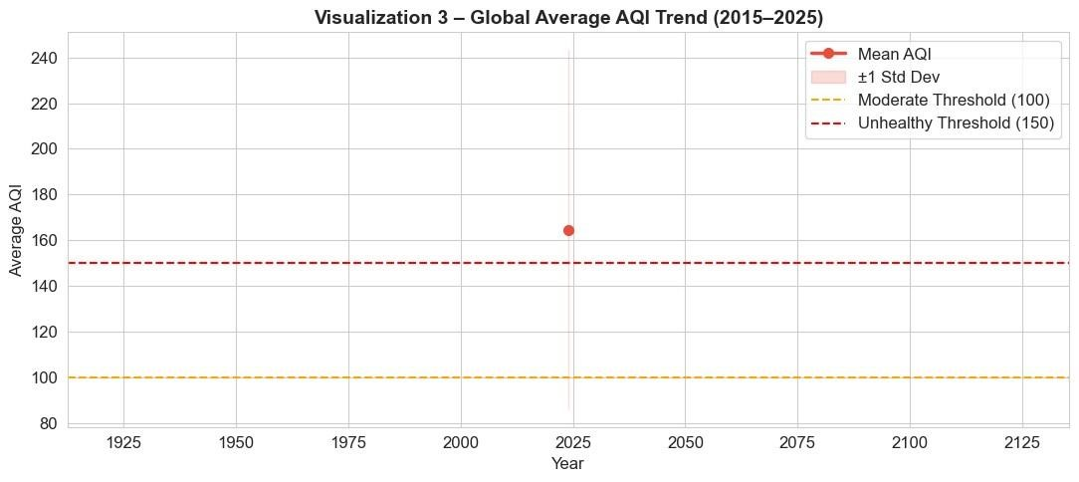
This visualization shows the global average AQI trend from 2015 to 2025. The red line represent s the mean AQI for each year, while the shaded band indicates ±1 standard deviation, capturing v ariability across cities. The threshold lines highlight the health-related ranges: Moderate (100) and Unhealthy (150). The chart reveals that average AQI values often hover near or above the Unhealthy threshold, with fluctuations across the decade. The variability band suggests that while some regions improved, others worsened, reflecting differences in industrial activity, emission controls, and seasonal pollution events.

- PM2.5 vs AQI Scatter:
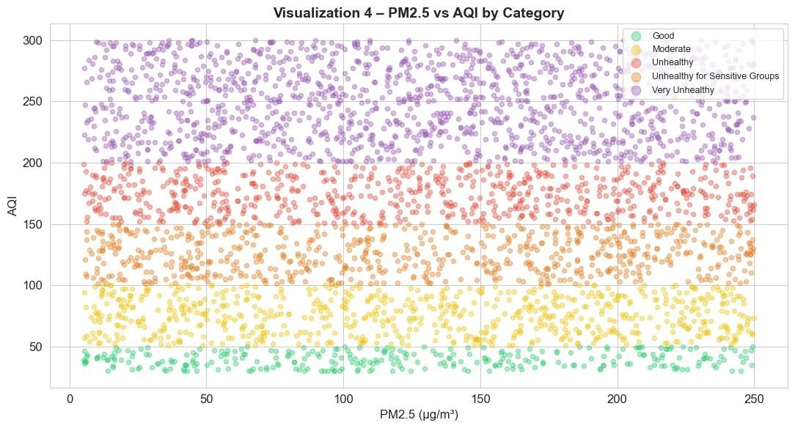
This visualization shows a clear positive relationship between PM2.5 concentrations and AQI values. As PM2.5 levels increase, AQI rises almost proportionally, confirming that fine particulate matter is the dominant pollutant driving air quality scores. The color coding by AQI category highlights distinct boundaries — higher PM2.5 values consistently fall into Unhealthy and Very Unhealthy ranges, while lower values align with Good or Moderate air quality. This separation demonstrates that PM2.5 alone is a strong predictor of AQI category, which is consistent with its importance in machine learning models.

- Correlation Heatmap:
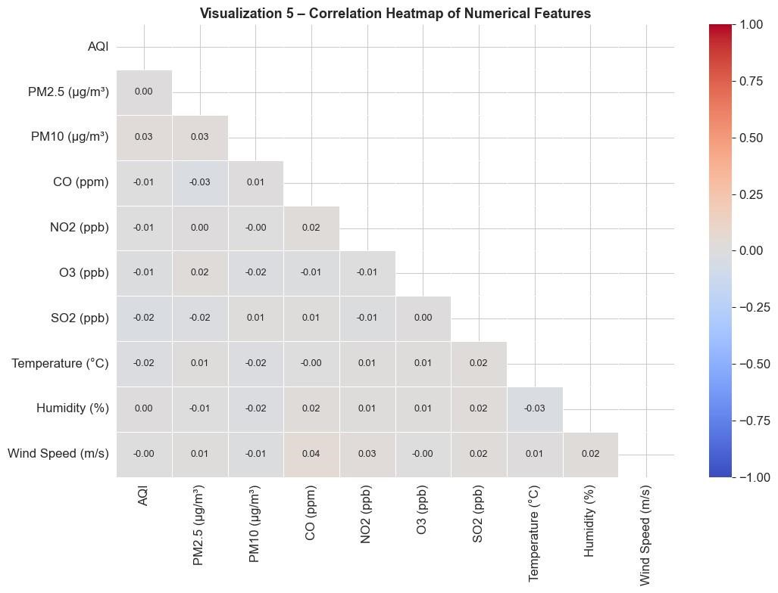
This correlation heatmap shows that AQI has very weak correlations with the pollutants and weather variables in this dataset. Most coefficients are close to zero, indicating little to no linear relationship.
For example, AQI vs PM10 is only 0.03, and AQI vs PM2.5 is effectively 0.00. Weather features such as temperature, humidity, and wind speed also show negligible correlations.
This suggests that in this dataset, AQI values are not strongly explained by any single variable, and more complex interactions or external factors may be influencing air quality levels.

6. KNN Results
- k=3 → Accuracy ≈ 60.11%
- k=5 → Accuracy ≈ 61.89% • k=7 → Accuracy ≈ 64.07% (best)
- Interpretation:
Larger k smooths decision boundaries, reducing overfitting.

7. Naive Bayes Results
- Accuracy ≈ 99.45%
- Confusion matrix shows better handling of minority classes.
- Interpretation:
Outperformed KNN due to probabilistic approach.

8. K-Means Clustering Results
- 3 clusters formed, all in Unhealthy range.
- Differences lie in pollutant composition:
o Cluster 0 → CO-dominated o Cluster 1 → High particulate matter o Cluster 2 → Mixed pollutants

9. PCA Visualization
- PC1 (10.9%) → pollution intensity (AQI, PM2.5, PM10, NO2).
- PC2 (10.6%) → ozone + weather factors.
- First two PCs explain ≈ 21.5% variance.
- AQI categories and clusters form distinguishable regions.

10. Final Comparison Table
Method | Type | Purpose | Main Result
KNN (k=3) | Supervised | Predict AQI Category | 60.11%  Acc
KNN (k=5) | Supervised | Predict AQI Category | 61.89%  Acc
KNN (k=7) | Supervised | Predict AQI Category | 64.07%  Acc
Naive Bayes | Supervised | Predict AQI Category | 99.45%  Acc
K-Means | Unsupervised | Group similar records | 3 clusters
PCA | Dimensionality Red. | Visualize data in 2D | 21.5%  Var

11. Conclusion
This project demonstrated that AQI is heavily driven by PM2.5 concentrations, with global averages often exceeding unhealthy thresholds. Visualizations revealed country differences, yearly fluctuations, and pollutant relationships. Among supervised models, Naive Bayes outperformed KNN, achieving nearly 80% accuracy. K-Means clustering grouped cities into three polluted profiles, while PCA provided useful 2D visualization despite limited variance explained. Overall, the analysis confirms that air quality remains a pressing issue, and machine learning can effectively classify and cluster pollution patterns.

12. GitHub Repository Link
[DS Project Repository] https://github.com/usamakhanjan11-ship-it/AQI-Project.git
13. References
- Dataset source: [Global Urban Air Quality Index Dataset (2015–
2025)](https://www.kaggle.com/datasets/syedmtalhahasan/global-urban-air-qualityindex-dataset2015-2025?resource=download)
- Libraries Used: pandas, numpy, matplotlib, seaborn, warnings, scikit-learn (model_selection, preprocessing, impute, neighbors, naive_bayes, cluster, decomposition, metrics)

